# ROBOT FRAMEWORK

**Prerequisite:**

1. Install Python and Check command **python –version**
2. Check PIP available and Check command **pip –version**
3. Install **pip install rpaframework -** for robot framework

**Tool used:**

1. IntelliJ

**Plugin Add in intelliJ:**

1. IntelliBot - supports Robot Framework

## Robot framework Project Creation:

Created project and Created Required Folders 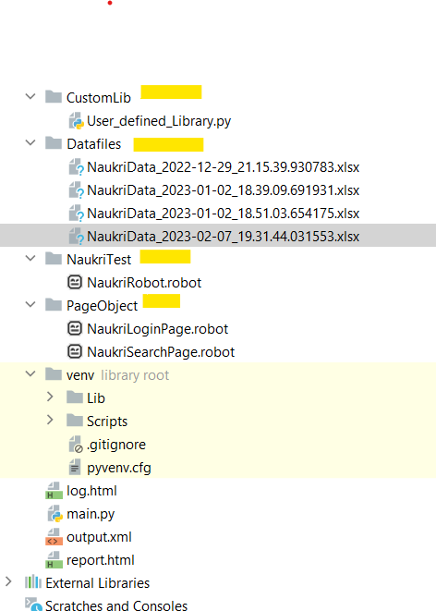

1. **To Create Robot file** - Create a file with **.robot** extension
2. Create robot files as required following POM Structure
3. User_defined_Library.py python file is used for create userdefined Library apart from ROBOT Framework.
4. Use of User_defined_Library.py python file to handle logic and python in feasible manner
5. Command to run the robot , Navigate to project and run

**“robot .\NaukriTest\NaukriRobot.robot”**

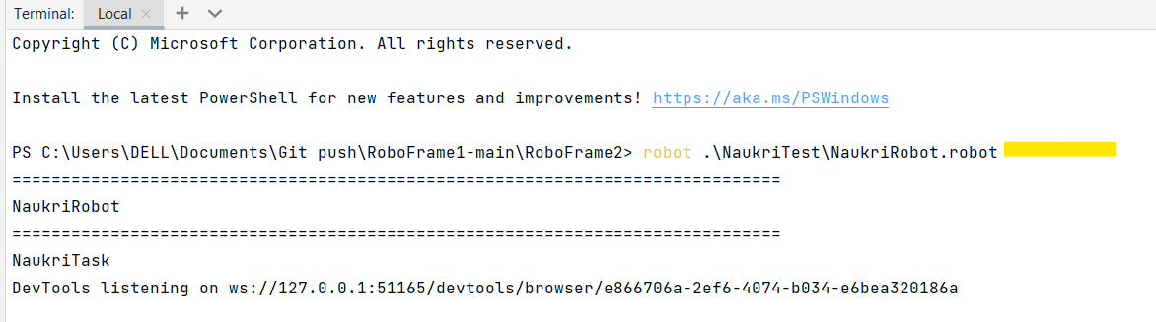

1. After running the Command report will be generated within same project repository 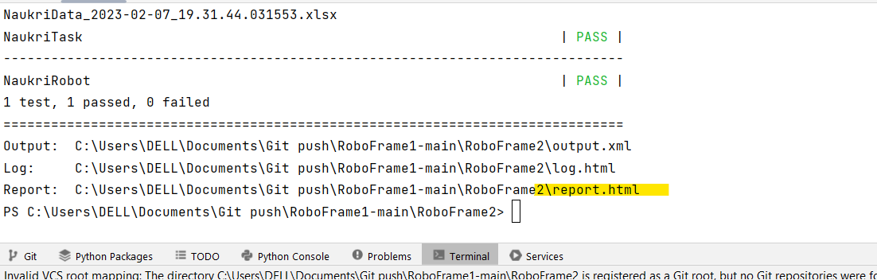

**Note:** For Basic understanding of Robot framework reference documentation

[*https://robotframework.org/robotframework/latest/RobotFrameworkUserGuide.html*](https://robotframework.org/robotframework/latest/RobotFrameworkUserGuide.html)

Robot file **NaukriRobot.robot:**

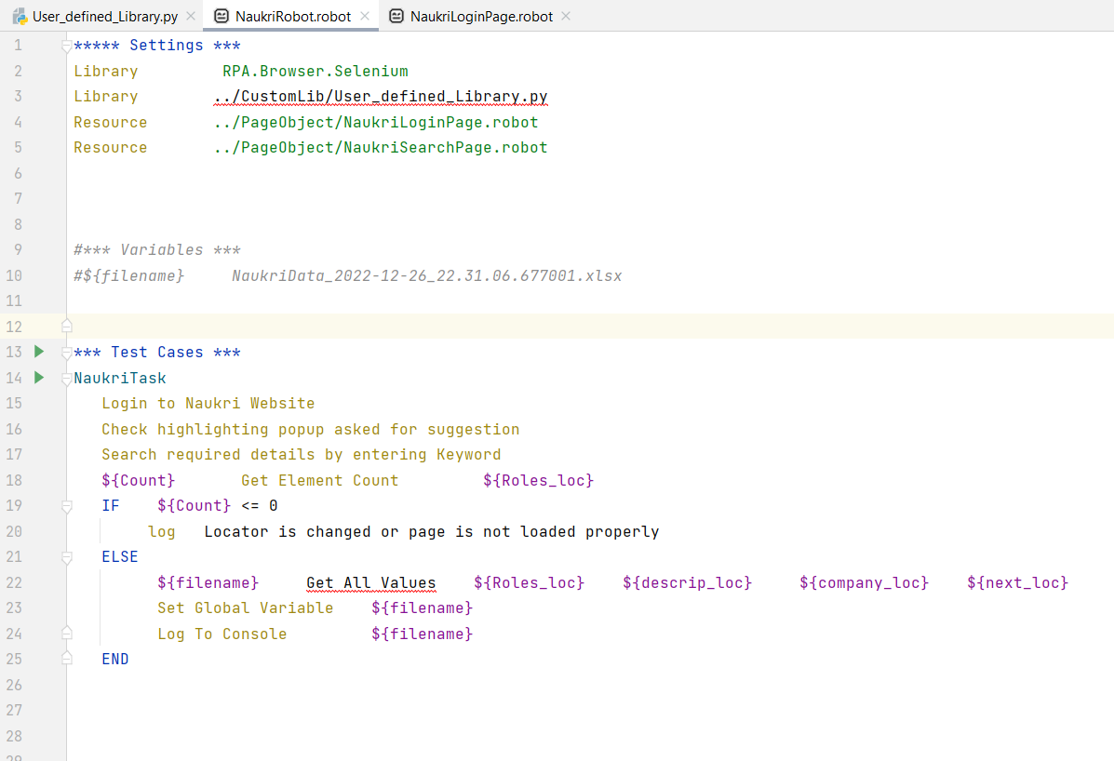

1. Used Library RPA.Browser.Selenium from RPAframework
2. Reference link for RPA.Browser.Selenium

<https://rpaframework.org/libraries/browser_selenium/>

1. RPA.Browser.Selenium to Control browsers and automate the web with SeleniumLibrary.

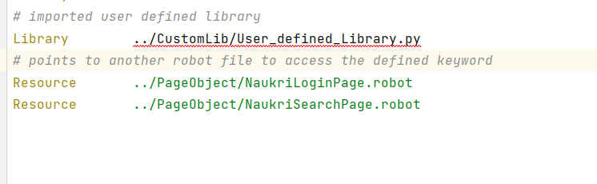

### Testcases:

*** Test Cases *** - used to define the test cases

1. NaukriTask is test case name
2. Keywords, variables inside the NaukriTask testcase are created and defined in other robot file which follows POM structure
3. Get ALL values is defined in user_defined_Library.py which follows logic using python code

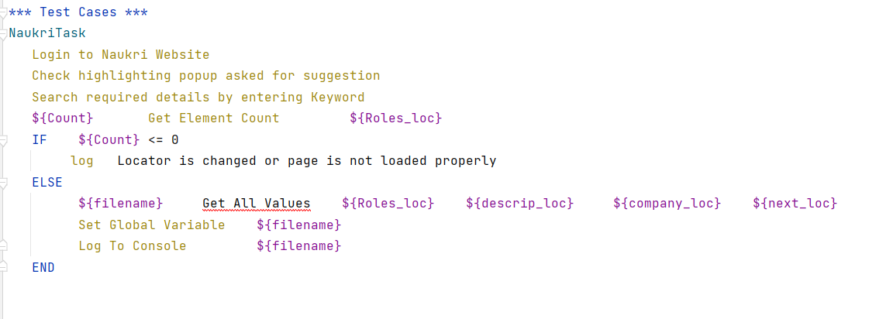

1. NaukriTask testcase definition given in below robot file

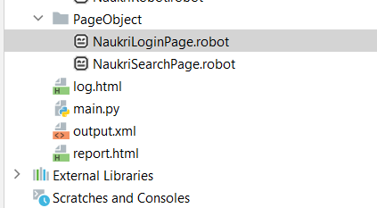

1. NaukriLoginPage

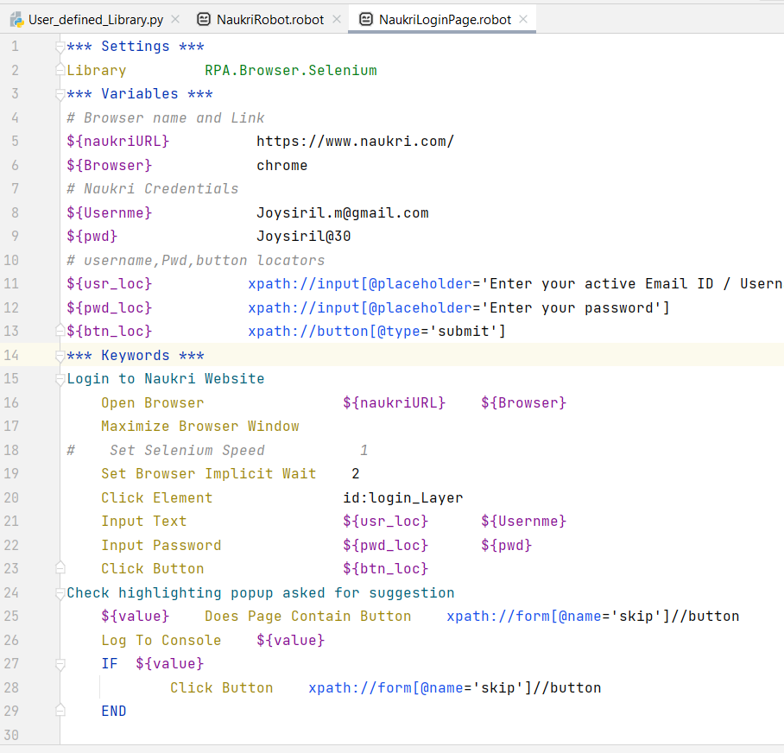

1. NaukriSearchPage.robot

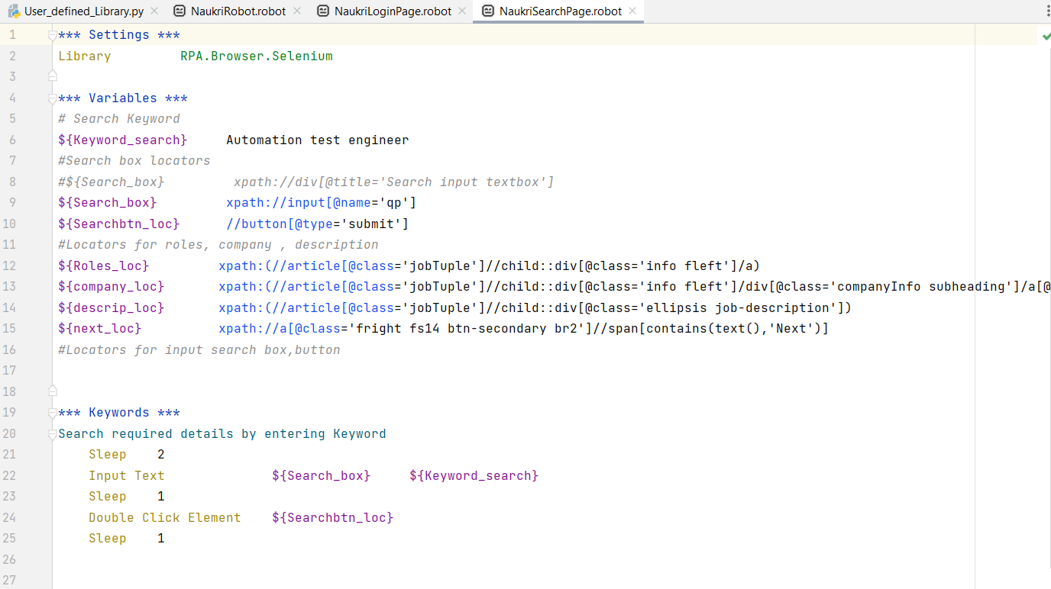

1. After running the command report will be report in same project repository

